Autonomous Underwater Surveillance Drone (AUSD)
Short Project Report for Best Student Project Award - ICICET 2026

Problem Statement and Objectives
Traditional underwater inspection and surveillance methods are often limited by harsh marine environments, high operational costs, and the risk to human divers. There is a critical need for autonomous systems capable of continuous, reliable, and high-resolution monitoring of underwater infrastructure, marine ecosystems, and security zones. The Autonomous Underwater Surveillance Drone (AUSD) addresses these challenges by providing an intelligent, unmanned solution for subaquatic data collection.

Objectives:
  - To design and develop a cost-effective, highly maneuverable underwater drone capable of autonomous navigation.
  - To integrate AI-driven object detection and anomaly recognition for real-time surveillance.
  - To ensure robust communication and data logging in challenging underwater environments.
  - To provide a scalable platform for applications ranging from pipeline inspection to marine biology research.

System Design and Methodology
The AUSD architecture is divided into three primary subsystems: the mechanical hull, the propulsion and control system, and the perception and intelligence unit.
Mechanical Design: The chassis is designed with hydrodynamic efficiency in mind, utilizing watertight enclosures rated for significant depth pressures. The modular frame allows for the easy addition or removal of sensor payloads.
Methodology: The development followed an iterative systems engineering approach. Initial CAD modeling was followed by computational fluid dynamics (CFD) simulations to optimize drag. The control methodology employs a multi-degree-of-freedom PID controller integrated with an extended Kalman filter for precise localization and attitude stabilization. The drone utilizes an un-tethered operational mode with periodic surfacing for high-bandwidth data transmission via radio or satellite links, while underwater communication relies on acoustic modems.

Key Technologies Used
The AUSD incorporates a blend of advanced hardware and software to achieve its autonomous capabilities:

Hardware Integration:
    - Processing Unit: A high-performance companion computer (e.g., Raspberry Pi) paired with a low-level microcontroller (e.g., Arduino Mega) for real-time motor control.

    - Propulsion: Brushless thrusters arranged in a vectored configuration for 6-DoF maneuverability.

Sensors:
    - IMU & Depth Sensors: For attitude heading reference and precise depth holding.
    - Vision Systems: High-definition low-light cameras and scanning sonar for obstacle avoidance and structural mapping.
    - Environmental Sensors: Ultrasonic sensors for object distance mapping.
  - AI/ML Models: Convolutional Neural Networks (CNNs) trained on custom underwater datasets for real-time target recognition (e.g., identifying cracks in pipelines or classifying marine life). Edge computing techniques are employed to run these models locally without requiring a continuous tethered connection to a surface station.

Experimental Results and Performance Analysis

Table : Performance Metrics of AUSD AI-Enhanced Systems:

Parameter | Metric | Achievement / Value
Detection Accuracy | Average (CNN-based) | > 70%
Navigation Precision | Average Position Error | < 1.0 Meter
Operational Endurance | Single Deployment | > 18 Hours
Recharge Trigger | Minimum Battery Threshold | 20%
Classification Focus | Target Types | Divers, Mines, USOs

Applications and Impact
The deployment of the AUSD has far-reaching implications across multiple sectors:
  - Industrial: Significant reduction in the cost and risk associated with inspecting submerged infrastructure such as oil rigs, bridge pilings, and telecommunication cables.
  - Societal: Enhances port security and coastal surveillance by providing rapid, un-tethered deployment capabilities to detect unauthorized underwater incursions or hazardous materials.
  - Academic/Scientific: Serves as a versatile platform for marine biologists and oceanographers to monitor coral reef health, map seabed topography, and study aquatic life without human interference.

Prototype Snapshots and Diagrams
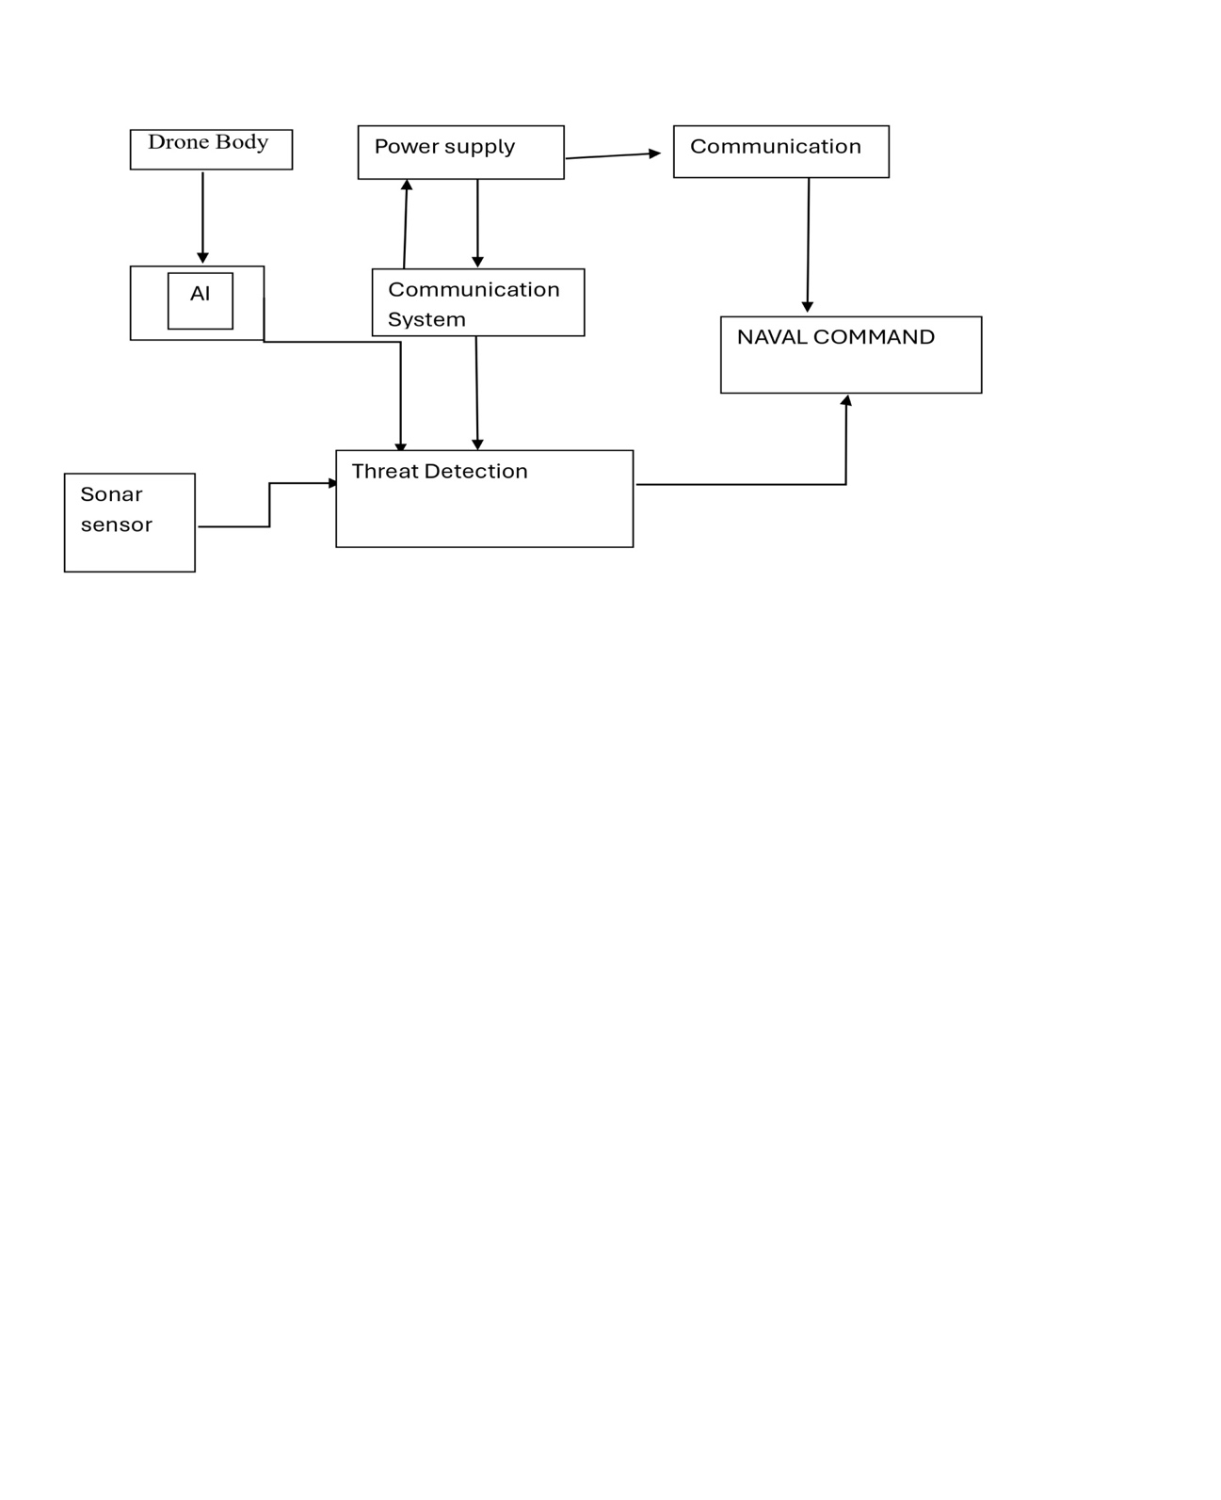

Fig 1: - Working Principle of the drone
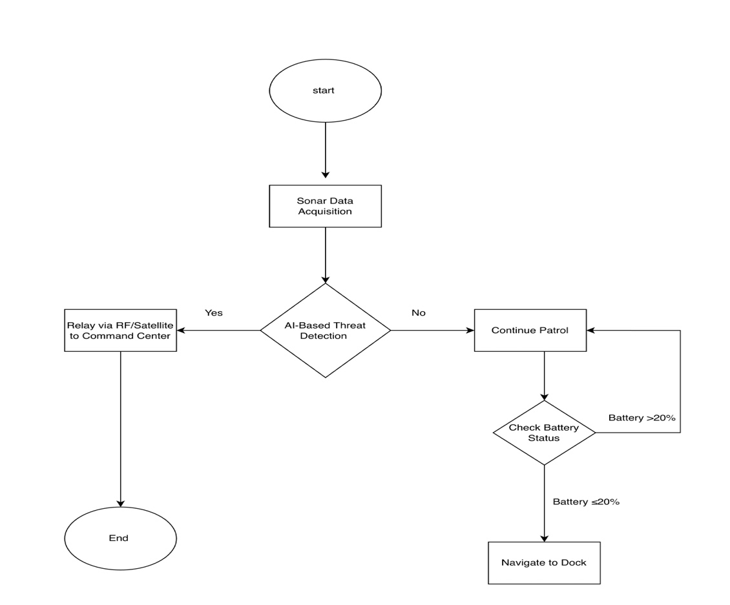

Fig 2: - FLOWCHART

